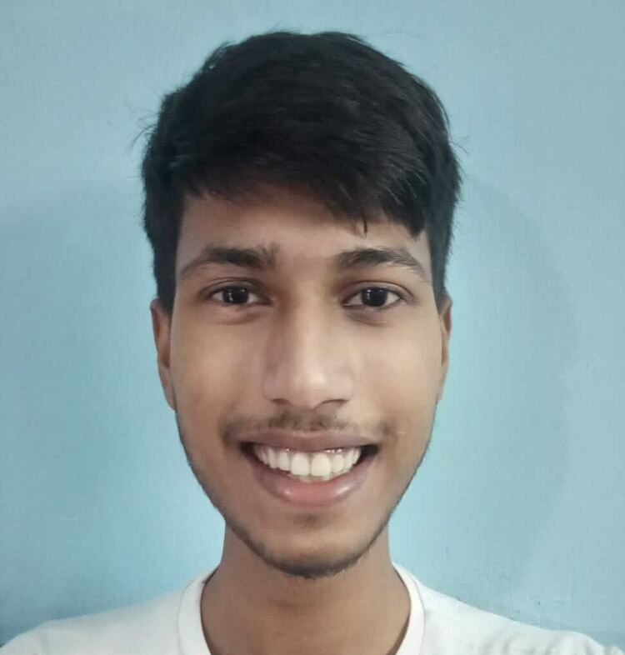 |  | Sachin rajbhar  Problem Solver, Mentor
Profile  YouTuber  Investor  BCA 1st sem Student  Contact  PHONE:  +91 8285895280  WEBSITE:  webidias.com  EMAIL:  officialsachinrajbhar@gmail.com  Hobbies  Electronics  Football  Manufacturing | Skill #1 MsWord  Skill #2 Ms excel  Skill #4 Web Dev  Skill #5 C language  Skill #6 App Dev | EDUCATION  DSEU Dwarka Sec-9  2021 - 2024  I am currently pursuing BCA from Dseu Dwarka Sector-9  Jinvani Bharti Public School  2016 - 2020  I Achieved a good critical thinking ability from my school because of pursuing Science with c++ & English subjects in 11th & 12th  WORK EXPERIENCE  Quick Order Pvt. Ltd. [Sales Part Time]  Feb 2021–Mar 2021  My total experience is 1 month, I have to call and convert clients for the product  [Grab your reader’s attention with a great quote from the document or use this space to emphasize a key point. To place this text box anywhere on the page, just drag it.]  SKILLS

